Self-Organizing Map (SOM) also known as Kohonen Map / Network

In my python program I have implemented 2 functions that incorporate the minisom library for the functions of an SOM neural network. One function depicts SOM with 2 image examples and the other function takes the breast cancer text file we were given in past exercises as a text example with SOM. Some of the plots I acquired after running the program are as follows, with more training and optimization of the parameters, maybe the outcome will improve.

Image Datasets from https://cs.uef.fi/sipu/datasets/

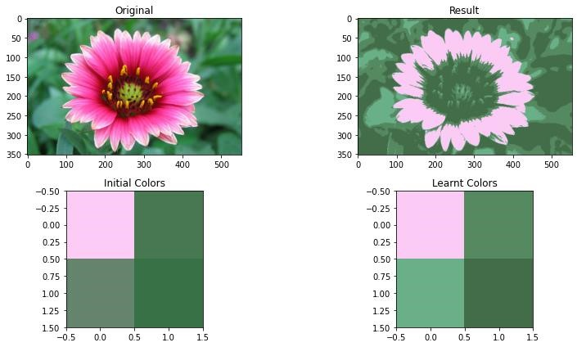

Output from som_with_image function.

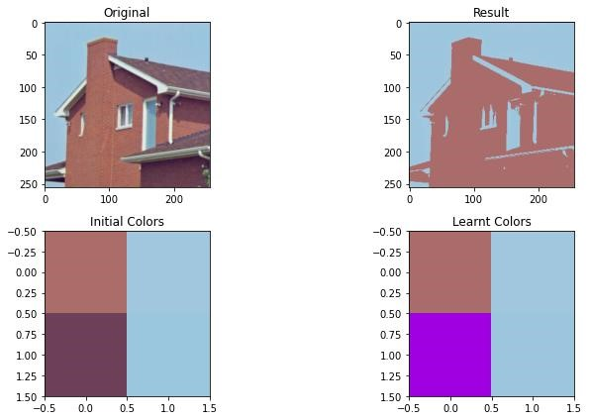

Output from som_with_images function. Input image from uef dataset collection site.

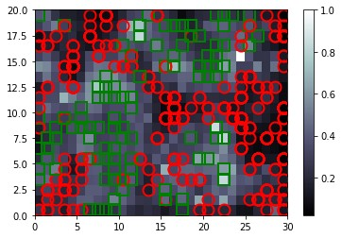

Output from som_with_data function. Breast cancer .txt file as an input.